**FORGERY DETECTION USING ELA AND CNN**

Project submitted to the

SRM University – AP, Andhra Pradesh

for the partial fulfillment of the requirements to award the degree of

**Bachelor of Technology**

In

**Computer Science and Engineering**

**School of Engineering and Sciences**

Submitted by

1. Ramoji Chintada (AP21110011497)

2.Ganesh (AP211100502)

3.Kalyan Ram (AP21110011516)

4.Ramsai Achanta (AP21110011554)

5. Blessy Srikanth B (AP21110011557)



Under the Guidance of

**(Hemanth Kumar Kalluri)**

**SRM University–AP**

**Neeru Konda, Mangalagiri, Guntur**

**Andhra Pradesh – 522 240**

**Dec, 2024**

**1. Abstract**

In the digital age, the manipulation of images has become increasingly common, making it difficult to trust the authenticity of images found online or in media. This project focuses on the development of an automated image forgery detection system using a combination of Error Level Analysis (ELA) and Convolutional Neural Networks (CNN). ELA is used to detect inconsistencies in the error levels of an image, which could indicate tampering. CNNs are then employed to classify images as either "real" or "fake" based on features learned from the ELA-processed images. The model is trained using a dataset of both authentic and forged images from the CASIA dataset, and performance is evaluated using accuracy, confusion matrix, and classification confidence. The goal of this project is to provide an effective and reliable solution for detecting forged images, which is vital for fields like media, law enforcement, and forensics.

**2. Problem Statement**

With the increasing use of digital images across various platforms such as social media, news outlets, and even legal frameworks, the authenticity of images has become a major concern. The rise of image manipulation techniques, such as deepfakes, has made it increasingly difficult to distinguish between genuine and altered images. This problem has far-reaching implications, especially in areas such as journalism, law enforcement, and forensics. Manual detection of forged images is time-consuming and often inefficient, leading to a need for automated systems capable of accurately identifying forged images.

This project seeks to address the challenge of image forgery detection by combining advanced image processing techniques (Error Level Analysis) and deep learning models (Convolutional Neural Networks). The aim is to create an automated system that can detect forgeries with high accuracy and efficiency, helping to mitigate the risks of image manipulation in various domains.

**3. Objectives**

The primary objectives of this project are:

* **Detecting Image Forgery**: The core objective of this project is to develop a model capable of detecting forged images, distinguishing them from authentic images. Image forgery detection plays a crucial role in maintaining trust and authenticity, especially in sensitive sectors like media and law enforcement.
* **Applying Error Level Analysis (ELA)**: This project utilizes Error Level Analysis (ELA) as a technique to identify inconsistencies in the image, highlighting potential tampered regions. ELA helps by analyzing the error between the original and recompressed versions of an image, allowing it to identify alterations that may indicate forgery.
* **Building a Convolutional Neural Network (CNN) for Classification**: A Convolutional Neural Network (CNN) is designed and trained to classify images as either "real" or "fake." CNNs are particularly suited for image classification tasks due to their ability to automatically detect relevant features from raw image data.
* **Model Evaluation**: After training the CNN on the dataset, the model’s performance will be evaluated using metrics like accuracy, confusion matrix, and classification confidence. The goal is to develop a model that can generalize well to new, unseen data and accurately detect forged images.
* **Optimizing Model Accuracy**: The objective is to achieve high accuracy in distinguishing between real and forged images, with the aim of achieving reliable and precise detection across various types of forgeries.

**4. Methodology**

**4.1 Error Level Analysis (ELA)**

Error Level Analysis (ELA) is a technique used to highlight areas in an image where inconsistencies or anomalies in compression might indicate tampering. The ELA method works by comparing the original image's compression error levels with the recompressed version. Forged regions typically have different compression characteristics compared to the rest of the image, making them detectable.

* **Steps**:
  + Load the original image and recompress it with a lower quality setting.
  + Calculate the error between the original and recompressed images.
  + Highlight areas of the image where these errors are significant, which might indicate potential forgery.

**4.2 Convolutional Neural Network (CNN)**

The project uses a Convolutional Neural Network (CNN) to classify images as real or fake. The CNN model consists of the following layers:

* **Convolutional Layers**: Extract spatial hierarchies from the images.
* **Pooling Layers**: Reduce the spatial dimensions to lessen the computational burden and retain important features.
* **Fully Connected Layers**: Use the features learned by the convolutional layers to perform classification.

The model is trained on a dataset of real and forged images (from the CASIA dataset) after preprocessing with ELA. The training process includes using the fit() function with a training and validation split. Early stopping is implemented to avoid overfitting.

**4.3 Performance Evaluation**

The model’s performance is evaluated using the following:

* **Accuracy**: The percentage of correctly classified images in the test dataset.
* **Confusion Matrix**: A matrix that shows the number of true positives, true negatives, false positives, and false negatives, helping to assess the classification performance.
* **Model Confidence**: The confidence of the model's predictions is also evaluated for each prediction.

**5. Results and Discussion**

The CNN model was trained using a large dataset of both real and forged images, and its performance was evaluated on a validation set. The results indicate that the model achieved an impressive accuracy rate of approximately **98.55%** on fake images and **98.64%** on real images, showing its effectiveness in distinguishing between real and forged images.

The confusion matrix further supports this result, showing a high true positive rate for both real and fake images, with only a small number of false positives and false negatives.

**Original Image**



**After converting to ELA image**

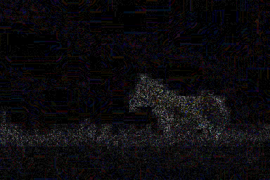

**Forgered Image**



**ELA Of Forgered Image**

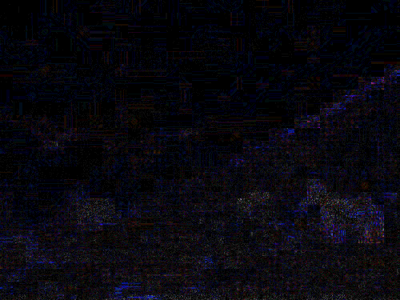

**loss and accuracy curves for training and validation**

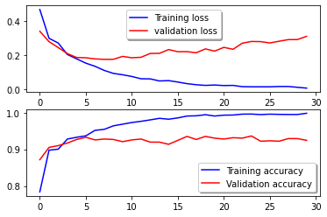

**6. Conclusion**

This project demonstrates that combining Error Level Analysis (ELA) and Convolutional Neural Networks (CNNs) provides a robust solution for image forgery detection. By leveraging ELA to highlight tampered regions and using CNNs to classify images, the system can accurately detect forged images, achieving high accuracy. Future work may include expanding the dataset, applying transfer learning, and exploring more advanced architectures to further enhance the model’s performance.